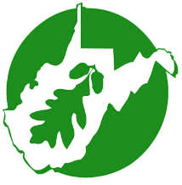
West Virginia Forestry Association 2008 Quarrier Street, Charleston, WV 25311 * 681-265-5019 * Email: wvfa@wvfa.org

2020 ELECTION CANDIDATE QUESTIONNAIRE

Congratulations. You are a candidate for public office in the general election. Holding elected office is a vital part of governing our democracy. We are interested in your views and policy positions on forest related issues in West Virginia.

Please take the time to read and consider responding to our questionnaire. We will share your responses with our members and the general public through our website www.wvfa.org . If you have questions, contact us at 681-265-5019 or email at wvfa@wvfa.org

Please state your name and the office you are a candidate:

Name

Office

Forestry is the art and science of managing forests to produce various products and benefits for the environment and society. West Virginia employs professional foresters to manage state-owned forests, to provide oversight for private forest management, to prevent uncontrolled wildfire, and to regulate possible timber harvesting impacts.

According to the most recent independent study, the forest products industry contributes $3.4 billion to West Virginia’s economy. West Virginia citizens reply upon the Division of Forestry to protect our forests and communities from wildfires, insects, disease, and timber theft.

- Would you consider any changes in funding for the West Virginia Division of Forestry?

West Virginia has 12 million acres of forests, 78% of the State, making it the third most forested State in the US. The following map shows who owns these forests. Privately owned forests dominate the landscape, with family forests, in smaller tracts comprising the largest segment. Property taxes and in the past, timber harvesting taxes, have been used to offset other tax revenues to balance State spending. Many studies have shown the impact of tax policy to forests, especially to individuals owning forest land.
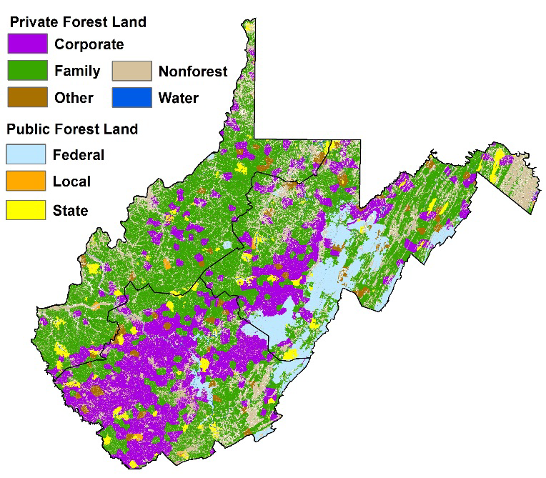

- Would you consider changes in taxes on undeveloped forests to balance the budget in West Virginia?

In general, trees are harvested for products, to improve environmental health, and to provide wildlife habitat. Removing mature trees in a stand provides the remaining trees more room to grow and reduces competition for nutrients, sunlight, and water. This reduction in competition results in healthier, vigorously growing trees, which help to keep our air and water clean.
Harvesting trees improves habitat for many wildlife species, large and small. Removing all or some of the trees in an area increases the amount of sunlight that reaches the forest floor and promotes the growth of shrubs, herbs, berries and other plants that provide both food and shelter for animals.
Trees also are harvested to make more than 5,000 products we all use every day. These products range from paper, lumber used to build houses, furniture and cabinetry, to a wide range of other products including toothpaste, ice cream, maple syrup, medicines, hair spray, chewing gum, molded plastics, soap, and shampoo. As our population grows, so does the demand for all of these products. Throughout the recent pandemic, forest products were deemed and shown to be essential to our health and well-being.
According to the most recent U.S. Forest Service inventory, West Virginia is harvesting about 50% of the annual net growth, which takes into account natural mortality, and the forests are largely older, larger trees that provide exceptional opportunities for a variety of wood products.
West Virginia relies heavily on wood processing facilities in surrounding states. For example, there is no paper mill in the State, no large biomass energy facility, and no large furniture or cabinet manufacturers. In fact, there are large parts of southern West Virginia where despite large tracts of over mature forests there is an obvious lack of wood consuming/processing facilities.
- With all these benefits from harvesting trees in West Virginia, what policy initiatives would you support to promote more harvesting, including harvesting on state forest and parks, value added manufacturing, and securing additional markets for West Virginia forest products?

West Virginia is faced with grave fiscal challenges to provide basic government services, pay for pension obligations, and invest in improving infrastructure, roads, bridges, and possibly remote access to technology, health care, and privately owned infrastructure like railroads. Rural communities depend on natural resource industries to move cattle, milk, coal, gas, wood to processing facilities that require good roads capable of handling large loads. Using additional axles on trucks has proven to lessen damage by reducing the number of trips and improving efficiency.
- Would you support increasing funding to rebuild rural roads and increase weight limits on Interstate highways conditioned upon additional axles to 94,000 lbs.?

The forest products supply chain requires a skilled, trained workforce working safely in a variety of conditions. Despite wages being among the highest for these workers, the workforce is aging. There is no vocational training for loggers, wood products equipment, and other forest related professions, some of which need a 2 or 4 year advanced degree in West Virginia. Forestry and wood science programs at West Virginia University and Glenville State College have diminished in scope and size.

- Would you support establishing a vocational program for logging and expanding the forestry program at State universities and colleges?

The forest products industry is unique in that it utilizes its own manufacturing by-products for many other uses. When a log is converted to lumber, other products including sawdust, bark, chips and slabs are produced and nearly 100% utilized. Bark and sawdust are generally used for mulch, bedding materials and for nursery use, while chips primarily go into paper making. Many wood by-products that aren't used for these purposes are converted to energy by burning them. In many instances, forest product manufacturing facilities produce enough electricity by burning these products to run their entire operations, and still have enough electricity left to sell back to the power companies! Renewable energy is an important national security concern for having a diversity of energy sources. Some forms of renewables (solar, wind) have flourished with incentives.

- Do you support incentives to increase biomass energy used as a renewable resource in West Virginia?

Forest industries include many types of manufacturing and even recreational users that depend on the mixture of public and private forests we have in West Virginia. The pandemic has exposed the vulnerability that all forest related businesses lack access to the capital to invest in new equipment. West Virginia’s tax on capital equipment further discourages investors from buying new equipment and simply encourages fixing older equipment that may be less safe and less efficient to operate.

- Would you support reducing or eliminating the business equipment inventory tax?

The House of Delegates passed a study resolution in 2020 to understand what is driving loggers insurance rates higher and specifically to look at the “Mandolidis” provisions of law. A Mandolidis case is also known as a deliberate intent case and refers to a situation where the employer intentionally places the employee in a dangerous working condition – unknown to the worker, but known to the employer. The forest industry is vulnerable to many of these cases because despite safety training and education, proper equipment, working in the forests and wood processing has inherent risks.
- What specific polices and reforms would you support to reduce business owners’ risk from lawsuits using the” Mandolidis“ provision?

